Workplace
Emergency
Response
Plan

SITE ADDRESS AND DETAILS
SteamRanger Location | Goolwa Depot
Address | 3327 Alexandrina Road GOOLWA, SA 5214
Building Classifications | 9b
Hours of Site Occupancy | Most days – Irregular depending on operations
Next WERP Review | March 2022

Table of Contents

1 Preface
1.1 Disclaimer
1.2 Purpose

1.3 Abbreviations and Acronyms
1.4 Definitions
1.5 Review Procedures
1.6 Records
1.7 Training
1.8 Communication

2 Goolwa Depot Emergency Contacts

3 Emergency Control Organisation
3.1 ECO Structure
3.2 Authority of SHR Wardens
3.3 Duties of the Emergency Control Organisation

4 Potential Emergencies at Goolwa Depot

5 Emergency Procedures for Goolwa Depot Occupants
5.1 General Evacuation
5.2 Emergency – Evacuation not required
5.3 Fire / Explosion (inc Bushfire)
5.4 Hazardous Material Incident
5.5 Emergency and Evacuation Lights
5.6 Emergency Guides
5.7 Goolwa Depot - Emergency Assembly Point
5.8 Goolwa Safer Place - Goolwa Railway Station

6 Portable Extinguisher Guide

Preface

1.1 Disclaimer
This document contains material to assist in meeting Work Health and Safety obligations under the Work Health and Safety Act and Regulations 2012, and AS3745-2010 - Planning for Emergencies in Facilities. The information is accurate at the time of publication.

1.2 Purpose
This Workplace Emergency Response Plan (WERP) outlines how SHR shall respond in the event of a workplace emergency and outlines the site-specific response structure, resources, procedures and practices that shall be implemented. The purpose of this plan is to minimise adverse impacts to people, property from an incident occurring or impacting on site.

1.3 Abbreviations and Acronyms
TERM | DEFINITION
BOM | Board of Management
CFS | Country Fire Service
ECO | Emergency Control Organisation | Not applicable
EPC | Emergency Planning Committee | Not applicable
ERG | Emergency Response Guide | Not applicable
ONRSR | Office National Rail Safety Regulator
PEEP | Personal Emergency Evacuation Plan
PPE | Personal Protective Equipment
SAAS | South Australian Ambulance Service
SAPOL | South Australia Police
SHR | SteamRanger Heritage Railway
TC | Train Control
WERP | Workplace Emergency Response Plan

1.4 Definitions
Chief Warden is the senior person on site at the time of an incident or a person nominated by SHR.
Wardens are team members who volunteer to assist the Chief Warden at the time of an incident or are nominated by SHR.
Team Members are SHR volunteers or paid employees
Special Needs are people on site (team members or visitors) who may need assistance in the event of an incident due to injury, permanent or temporary mobility, sensory or other impairment

1.5 Review Procedures
The SHR shall review this plan as directed in response to organisational and/or legislative changes and requirements defined by BOM in consultation with workers, and other relevant parties. This emergency plan shall be reviewed annually or whenever:
- Controls are no longer effective
- Changes on site are likely to introduce new or different hazards that current controls will not adequately address
- A new hazard or risk is identified
- Results of consultation indicate a review is needed
- Requested by workers
- Contact or staff details change
- Legislative changes

1.6 Records
All versions of the plan shall be kept as a record. If a notifiable incident occurs, the relevant plan and supporting documentation (initial and reviewed versions) shall be kept for 2 years post-incident.

1.7 Training
All team members including contractors working onsite will be provided with appropriate training on the procedures detailed in this WERP, with emphasis on personal safety, authority of the Chief Warden, emergency contacts and location of the Emergency Assembly Point.
New team members and contractors working on site must receive this training before commencing any work with SHR
Training records are maintained by SHR.

1.8 Communication
A current copy of this WERP is also displayed at Goolwa Depot and on the Staff Section of the SHR website.

- Goolwa Depot Emergency Contacts

EMERGENCY SERVICE CONTACTS
Police | SAPOL – 000
Fire | CFS - 000
Ambulance / Medical | SAAS – 000
State Emergency Service | SES – 132 500
Poison Information Centre | 13 11 26
Safework SA | 1800 777 209 (BOM use only)
ONRSR | 8406 1500 (BOM use only)

SHR EMERGENCY CONTACTS
Train Control | 8391 2719
Mt Barker Depot | 7285 6350
Victor Harbor Station | 8552 2782

- Emergency Control Organisation

3.1 ECO structure

SHR
Wardens
Chief Warden
(Senior SHR person on-site)
SHR
First Aid Officers

3.2 Authority of SHR Wardens
Once an emergency has been identified, the powers of the SHR Chief Warden and SHR Wardens override all normal non-emergency management procedures. The SHR Chief Warden and SHR Wardens are authorised to marshal and evacuate all occupants from the buildings and rollingstock.
Persons refusing to comply with a warden
If a person refuses to comply with the direction of a SHR Warden, the Warden will:
- Be firm and assertive in requesting the person to cooperate or evacuate due to the emergency
- Immediately communicate information the Chief Warden who will notify the responding emergency services where lawful action can be taken to remove the person.

3.3 Duties of the Emergency Control Organisation

Chief Warden
- Make themselves familiar with the contents of this Workplace Emergency Response Plan
- Respond to emergencies at the SHR Goolwa Depot
- Marshal and evacuate occupants from buildings, rolling stock or the site as appropriate
- Assist in the evacuation of “Special Needs” persons
- Liaise with and provide information to Emergency Services that will assist with the management of the incident
- Provide Train Control with regular updates on the progress of the incident
- Monitor the servicing and maintenance of emergency systems and equipment and report deficiencies in writing
- Ensure escape routes are kept clear from obstruction and emergency exits are accessible and serviceable
- Be familiar with the layout of the site, including the location of emergency equipment

Wardens
Note – Any SHR team member can volunteer to perform the role of a warden if requested by the Chief Warden
- Maintain communications with the Chief Warden
- Under the direction of the Chief Warden respond to emergencies in the buildings, rolling stock or the site as appropriate
- Marshal and evacuate building occupants to safe refuge or to Emergency Evacuation Points
- Assist in the evacuation of “Special Needs” persons to a safe refuge or to Emergency Evacuation Points
- Ensure escape routes are kept clear from obstruction and emergency exits are accessible and serviceable
- Be familiar with the layout of the buildings, and the site including the location of emergency equipment

First Aid Officers
- Collect a first aid kit and proceed to the safe refuge or Emergency Assembly Point
- Provide first aid to any person injured as a consequence of the emergency.

- Potential Emergencies at Goolwa Depot
An emergency is any event, that endangers the health and safety of SHR team members, contractors and visitors to the workplace and requires immediate response.
Emergencies that could potentially occur at Goolwa Depot include:
Event | Source of Cause | Possible Consequences
Fire / Explosion  (inc Bushfire) | Internal / External | Injury to persons, death, loss of assets, building damage, business disruption/cessation
Hazardous Materials Emergency  - Spills  - Gas leak  - Air Quality  - Toxic Emission | Internal/External | Injury to persons, death, environmental impact, business disruption/cessation
Building / Temporary Structure Damage | Internal | Injury to persons, death, loss of assets, building damage, environmental impact, business disruption/cessation
Traffic accident  Rail accident | Internal | Injury to persons, death, loss of assets, building damage, business disruption/cessation
Severe weather | Internal / External | Injury to persons, death, loss of assets, building damage, business disruption/cessation
Industrial accident | Internal | Injury to persons, death, loss of assets, building damage, business disruption/cessation
Medical emergency | Internal | Injury to persons, death, business disruption/cessation

Other types of potential emergencies:
The list of emergencies following are extremely rare or are unforeseeable and are likely to require unique responses under the direction of emergency services:

- Biological / Radiological
- Civil disorder
- Earthquake
- Terrorism
- Bomb Threat
- Securiity
- Active, armed shooter

- Emergency Procedures for Goolwa Depot Occupants
5.1 General Evacuation
General  Evacuation is required | - Raise the alarm by alerting workers nearby and wardens  - Call the Emergency Services - Dial 000 or Dial 112 if using a mobile phone  - Follow directions of Wardens  - Assist people with special needs  - The Senior Warden will direct all occupants to evacuate to the Emergency Assembly Point and make decisions on the immediate management of the incident.  - Do NOT re-enter until advised ‘all clear’.  - WHEN SAFE, NOTIFY – SHR Train Control on  8391 2719  - Submit a SHR Safety Report

5.2 Emergency – Evacuation not required

Evacuation not required | - Raise the alarm by alerting workers nearby and wardens  - Call the Emergency Services - Dial 000 or Dial 112 if using a mobile phone  - Follow directions of Wardens  - Assist people with special needs  - The Senior Warden will assess the incident and make decisions on the immediate management of the incident.  - Do NOT re-enter until advised ‘all clear’.  - WHEN SAFE, NOTIFY – SHR Train Control on  8391 2719  - Submit a SHR Safety Report

5.3 Fire / Explosion (inc Bushfire)

R | Rescue or Relocate people in immediate danger if you can do so without endangering yourself  - Assist persons with special requirements (e.g. disabled persons, small children)  Note: assist others after you have ensured your own safety first  - Exit via a safe fire exit.
A | Sound the Alarm: Advise others of the situation  - Call the Emergency Services (Country Fire Service) Dial – 000 or Dial 112 if using a mobile phone  Note: ensure that you are at a safe distance from the emergency incident, before calling  - If in doubt whether the situation is serious, you must still call the Emergency Services  - Use appropriate PPE
C | Confine the fire or hazardous material  - Close all doors, windows and other openings, and shut off piped and compressed gas as you are EVACUATING  - Ensure no personnel (emergency service personnel excluded) re-enter the building/facility until emergency services have confirmed and advised it is safe to do so.
E | Evacuate the area  - Evacuate as directed by the Wardens or when it is unsafe to remain in the area.  - Extinguish fire or contain hazardous material only if you have been trained and you are confident that it is safe to do so.  - Ensure all occupants of the building have been evacuated to assembly area  - First aid officers collect first aid kit and defibrillator (if available) and proceed to the Emergency Assembly Point  - Account for all personnel at the designated assembly areas.

Bushfire
Use the RACE procedure as described above then:
- Closely monitor the approaching bushfire for speed and intensity
- Evacuate by private vehicle into Goolwa Railway Station which is within the CFS designated ‘Goolwa Safer Place’ area.
- If it is safe to do so secure the site (lock gates)
- At Goolwa Railway Station the Chief Warden must conduct a roll call of team members
IMPORTANT – Do not leave evacuation to the ‘last minute’

5.4 Hazardous Material Incident
R | Rescue or Relocate people in immediate danger if you can do so without endangering yourself  - Assist persons with special requirements (e.g. mobility impaired)  - Exit via a safe exit.
A | Sound the Alarm. Advise others of the situation. Secure the area  - Emergency Services (Country Fire Service) Dial – 000 or Dial 112 if using a mobile phone  Note: ensure that you are at a safe distance from the emergency incident, before calling  - Assess the material using Safety Data Sheets (SDS)  - Use appropriate PPE (e.g. protective clothing for chemical spills).
C | Contain spill/escape if possible or use absorbent materials  - Contain hazardous material only if you have been trained and you are confident that it is safe to do so.
E | Evacuate the area on direction from the Wardens or when it is unsafe to remain in the area. (e.g. downwind of toxic fumes)  - Ensure all occupants of the building/facility have been evacuated to emergency assembly point or alternative safe location  - First aid officers collect first aid kit and defibrillator (if available) and proceed to the Emergency Assembly Point  - Account for all personnel at the designated assembly areas.

5.5 Emergency and Evacuation Lights

Emergency Exit lights are illuminated at all times and are provided with battery backup in the event of a power failure. Exit signs indicate the direction an occupant must take to evacuate to a safe place.

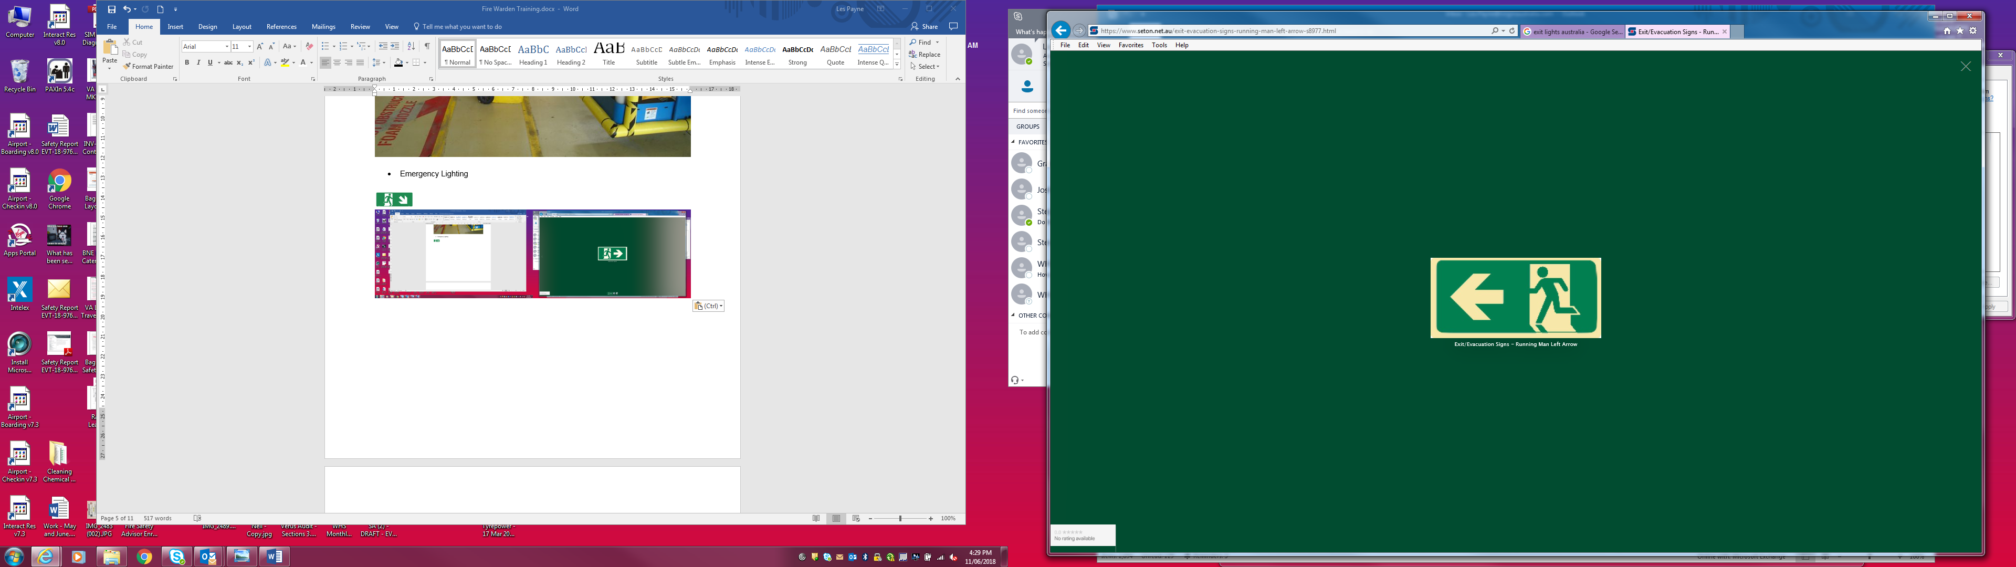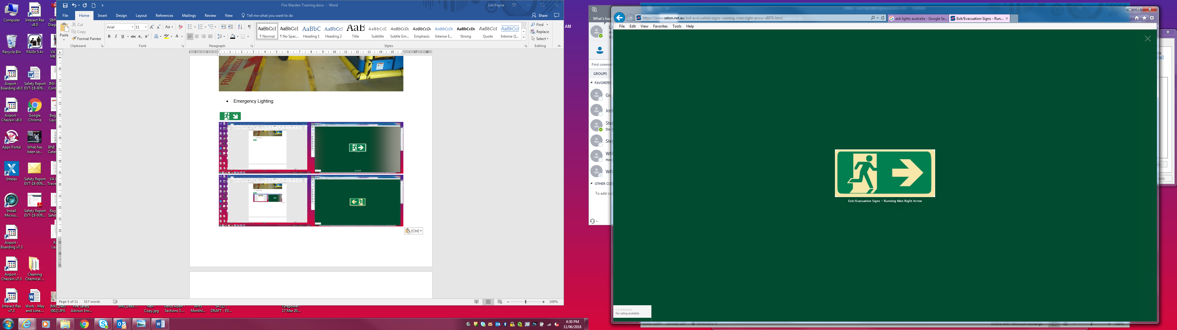
“From this point, go
straight ahead”
“From this point,
go left”
“From this point,
go right”

5.6 Emergency Guides
EMERGENCY GUIDE – CHIEF WARDEN
On hearing an ALERT, the Chief Warden should immediately assemble outside the workshop shed adjacent to the smoko area.
The Chief Warden should not leave this area unless it becomes unsafe to remain there. If this is the case relocate to the EAP
Take control of incident management until the Emergency Service take control
Ascertain the nature and location of the incident and have Wardens evacuate all occupants to the EAP or to a safer alternative EAP as appropriate
Immediately contact the Emergency Services no matter the severity of the incident
Contact Train Control and advice that an emergency incident is in progress
Have Wardens search the area including isolated areas and toilets – if safe to do so.
Take notes of the progress of the incident and observations. These may be useful at a future investigation of the incident
Provide regular incident updates to Train Control
Liaise and assist the Emergency Services with information that may assist with the management of the incident
The Chief Warden can delegate some tasks such as take notes, photographs and updates to Train Control to a Warden or other team member
No person will be directed to put their personal safety or the safety of others at risk at any time

EMERGENCY GUIDE – WARDEN
On hearing an ALERT Wardens should immediately assemble outside the workshop shed adjacent to the smoko area:
If this location is unsafe, immediately relocate to the EAP
Wait for direction from the Chief Warden
At the direction of the Chief Warden check the area for the cause of alert
If you discover fire (or other emergency), remove all persons from the danger area
Report all information discovered to the Chief Warden – type and location of the incident
If the alert was an error (false alarm) inform the Chief Warden immediately
Commence evacuation of the incident area to the EAP using the nearest safe exit
At the direction of the Chief Warden search the area including isolated areas and toilets – if safe to do so.
Confirm to the Chief Warden when the area has been completely evacuated
Proceed to the EAP and wait for further direction from the Chief Warden
Manage the EAP to ensure evacuees remain at the EAP if possible.
Wardens should never put their safety or the safety of others at risk at any time

Wardens Assisting Persons with Special Needs
Persons with special needs may include the following:
- Permanent or temporary mobility, sensory or other impairment
- Injured persons.
Assisting persons with special needs:
- Obtain assistance from other persons to evacuate the individual
- Advise the Chief Warden that a person with special needs is in the building and is being evacuated.
- Persons with special needs should be guided to the EAP.
- Avoid obstructing evacuation routes
- Persons with special needs should not be left unattended at any time

EMERGENCY GUIDE – FIRST AID
Collect portable first aid kits
Evacuate to the EAP as directed Chief Warden
Request assistance from team members to assist with first aid duties if necessary
If medical treatments are required, arrange with the Chief Warden to notify the SAAS
Provide update reports to the Chief Warden if appropriate
Take directions from the Chief Warden

5.7 Goolwa Depot - Emergency Assembly Point
The Emergency Assembly Point is located near the main vehicular entrance to Goolwa Depot.
During evacuations do not obstruct the site entrance as Emergency Services will enter the site by this route.
In the event of a security emergency or hazardous chemical spill it may be necessary to use an alternative, unidentified EAP or remain in designated buildings and lock down
Emergency Assembly Point
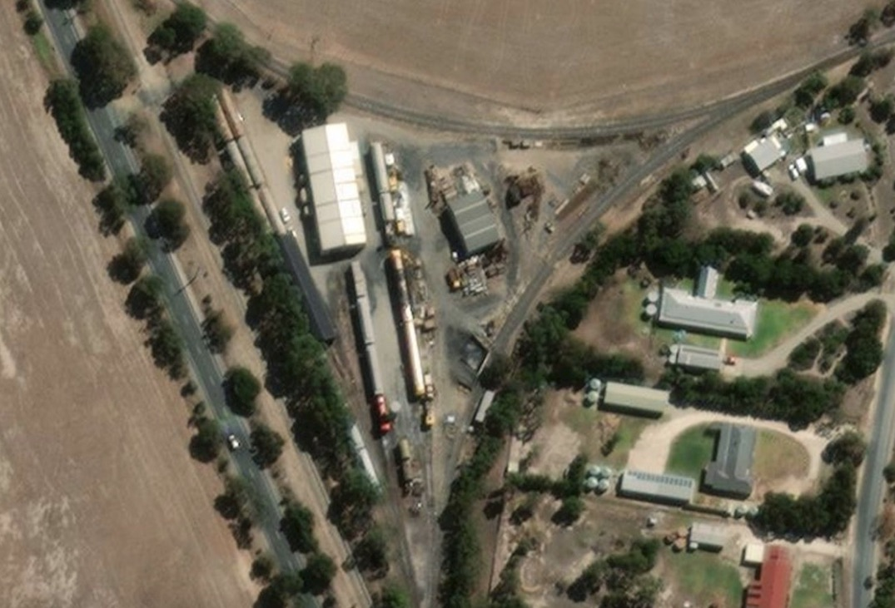
Chief Warden

5.8 Goolwa Safer Place - Goolwa Railway Station
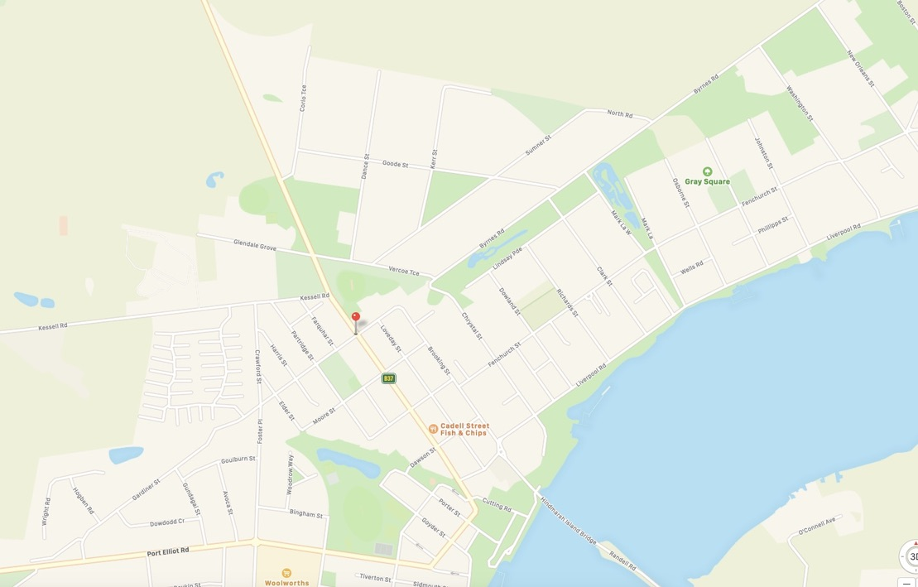
Goolwa Railway Station
Dunbar Road Goolwa
SHR Goolwa Depot
3327 Alexandrina Road Goolwa

- Portable Extinguisher Guide
NOTE - Wet Chemical Extinguishers and Vaporizing Liquid Extinguishers are uncommon and are not listed here |  | Type of fire, class and suitability
 |  | Class A | Class B | Class C | Class D | Class E | Class F
Type  Identification | Extinguishing Agent | Carbonaceous Solids  Wood, paper, plastic, rubber | Flammable & combustible liquids  Fuel, oil, paint | Flammable Gases  LPG, natural gas, acetylene | Metals  Sodium, magnesium, aluminium | Energised Electrical Equipment | Cooking Oils and Fats
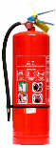 | WATER | YES | NO | NO | Specialised extinguishers are required for this fire type  Do not attempt to extinguish. Contain fire if safe to do so. | NO | NO
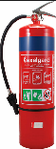 | FOAM | YES | YES  Unsuitable for use on alcohol and acetone fuelled fires | NO |  | NO | LIMITED
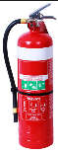 | DRY CHEMICAL POWDER | LIMITED | LIMITED | YES |  | YES | NO
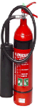 | CARBON DIOXIDE | YES | YES | NO |  | YES | NO
FIRE BLANKET |  | LIMITED | LIMITED | NO |  | NO | YES

© - Copyright. The copyright of this Emergency Response Plan is L.R. (Les) Payne of Willunga SA 5172. SteamRanger Heritage Railway of Mt Barker SA 5251 is an authorised user.

