WORK SAFETY ALERT – 22 / 02
ELECTRICAL SAFETY

APPLICABLE TO ALL STEAMRANGER WORKERS
EFFECTIVE FROM APRIL 1, 2022
________________________________________________________________________

Electricity has been an intrinsic part of daily life for over 140 years. It is an inescapable fact that we cannot live without electricity, but its deadly potential is often overlooked, underestimated or misunderstood. Electric shock, electrocution (death), fire, equipment failure and operational disruption are ever present potential hazards.
In the industrial context in which SteamRanger operates, Workplace Health and Safety Regulation are very specific about how electrical hazards must be managed to ensure a safe working environment.

This Work Safety Alert is published to provide you with information about how you can work safely with electricity in SteamRanger workplaces.

- Single phase 240 volt and three phase 415 volt AC systems are most commonly encountered mains electricity and portable generators in the workplace and at home. Both are potentially lethal
- Fire is a potential hazard in both mains electricity (240/415 volts AC) and very low voltage DC systems such as 6 volt to 50 volt systems used in rolling stock and motor vehicles
- Always inspect equipment, cords, extension cords, plugs sockets and switches for damage or faults before using. All cords and extension cords should have a current electrical “test tag” attached near the plug end. If there is damage, faults or no test tag, you should remove the item from the workplace immediately and advise you team leader. Your team leader will arrange for repairs replacement or testing before the item is returned to service.
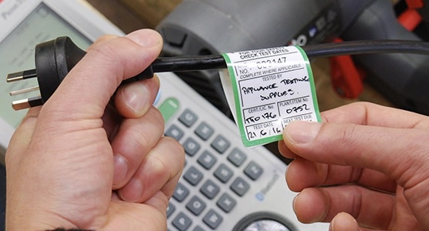
- You might be a great handyperson but unless you are also a licensed electrician, it is illegal for you to repair, modify or install any electrical equipment, cords, extension cords at SteamRanger workplaces.
- Never use electrical tape or duct tape to repair damaged insulation on equipment, cords or extension cords
- Avoid laying extension cords across rails, rollingstock or other metallic surfaces where practical.
- Use battery powered or compressed air hand tools wherever practical.
- All electrical equipment must be protected by a Residual Current Device (also known as a RCD or Safety Switch). RCDs can be a permanent installation at the main Switch Board or a portable “Power Box”
- Never use 10amp to 15 amp adapter cords or modify 15 amp plugs by filing the earth pin to fit 10 amp sockets. These practices are illegal and potentially hazardous.
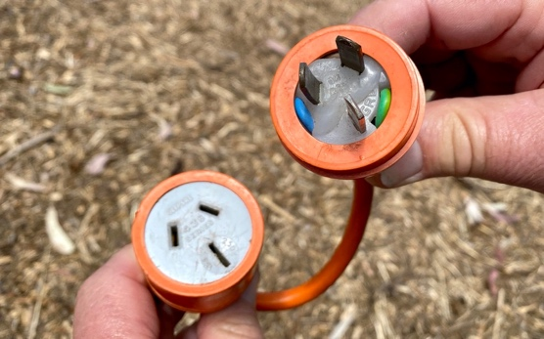
T
- Steam Ranger will progressively phase out domestic duty extension cords and power boards in its workplaces as they become damaged or surplus to requirements. These are usually white of grey in colour.
T
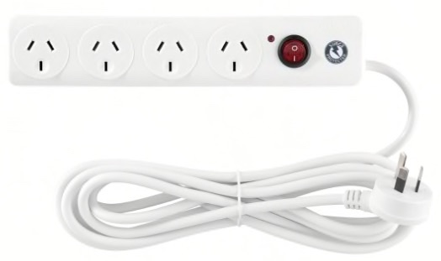
- All future purchases of extension cords should be Heavy Duty grade. These are usually orange, yellow or sometimes red. RCD protected Power Boxes will replace domestic duty power boards
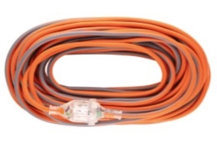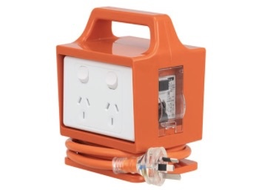
R
- Double adaptors and “piggy back plugs” are not to be used at any SteamRanger workplaces
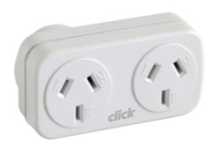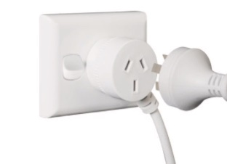
T

- Never “Daisy chain” power boxes (or power boards) – connect a power box into another power box.

- Do not use carpet to protect cords as there is the potential for the cord to be damaged on the abrasive surface beneath. Suspend cords above the walkway if possible or use a cable protector.
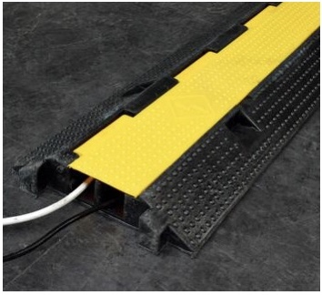
R

Read this - Electric Shock
Any electric shock has the potential to case temporary or permanent heart damage or even death up to several hours after the initial electric shock even though the casualty might appear quite well.
For this reason, you must seek immediate medical monitoring and treatment after receiving an electrical shock.
- As with any hazards, incidents or injuries in SteamRanger workplaces you must immediately advise your team leader and report the matter in writing. This includes electric shock, electrical fires and electrical short circuits

Reporting – Hazards, Incidents and Injuries
If you are involved in an incident, you are injured or witness an incident or a workplace safety hazard, you should immediately report this in writing and to your team leader. There are absolutely no penalties for reporting genuine work safety issues and you can even report hazards or incidents anonymously if you prefer.
SteamRanger will investigate all reports. Reporting is supported by the WHS Act 2012.

For display in all Guard’s Compartments, Mt Barker Station, Mt Barker Depot Office, Goolwa Station, Goolwa Depot, Victor Harbour Station.

